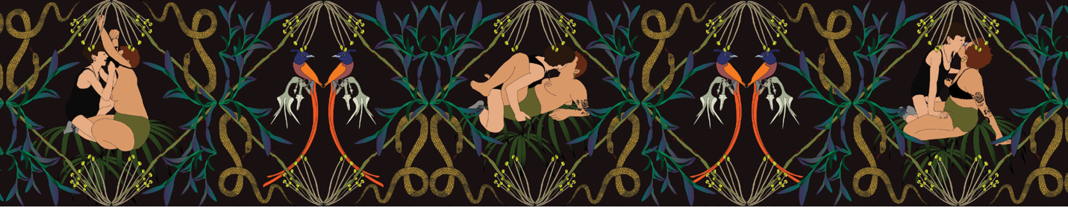
Illustration:
Şafak Şule Kemancı

Lesbian Lives 2025
Sponsorship Opportunities

 | Opportunities | Contribution |  |  | Recognition
Morning Coffee and Pastries – Saturday |  |  | $2,500 |  |  | Signage at event; advertisement in print program
Morning Coffee and Pastries – Saturday |  |  | $2,500 |  |  | Signage at event; advertisement in print program
Lunch – Friday |  |  | $7,500 |  |  | Signage at event; brief welcome at lunch; advertisement in print program
Lunch – Saturday |  |  | $7,500 |  |  | Signage at event; brief welcome at lunch; advertisement in print program
Afternoon Coffee  – Friday |  |  | $1,000 |  |  | Signage at event; recognition in print program
Afternoon Coffee  – Saturday |  |  | $1,000 |  |  | Signage at event; recognition in print program
Afternoon Reception  – Friday |  |  | $5,000 |  |  | Signage at event; brief mention at reception; advertisement in print program
Afternoon Reception  – Saturday |  |  | $5,000 |  |  | Signage at event; brief mention at reception; advertisement in print program
 | Gift Bags |  |  | $4,000 |  |  | Logo on gift bag to complete art and design of Lesbian Lives 2025

Partial sponsorships are available; please contact Julie or Ella to discuss.

Travel Bursaries

Lesbian Lives is committed to making the conference accessible to international scholars particularly from the global south, the Pacific Rim, and Muslim countries.
Sponsorship of travel bursaries in the amount of $1,500 for an international scholar will defray travel costs for the conference.
Contributions to travel bursaries will be recognized in the print program.

Sinister Wisdom, a US 501c3 organization, is the fiscal sponsor of the conference. Contributions are tax-deductible.

